**SECURITY MONITORING DASHBOARD**

**4.1 No of Fivetran roles**

select distinct role_id

from FIVETRAN.FIVETRAN_LOG.RESOURCE_MEMBERSHIP;

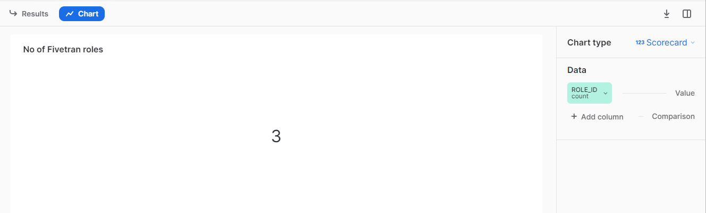

**4.2 No of Fivetran Users**

select count(given_name) as USER

from FIVETRAN.FIVETRAN_LOG.USER;

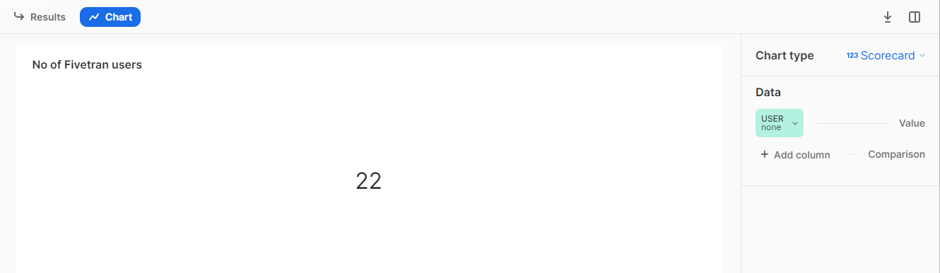

**4.3 FIVETRAN ROLE_ID VS ASSIGNED USER**

select user.given_name,rm.role_id

from FIVETRAN.FIVETRAN_LOG.USER

inner join

RESOURCE_MEMBERSHIP rm on user.id=rm.USER_ID;

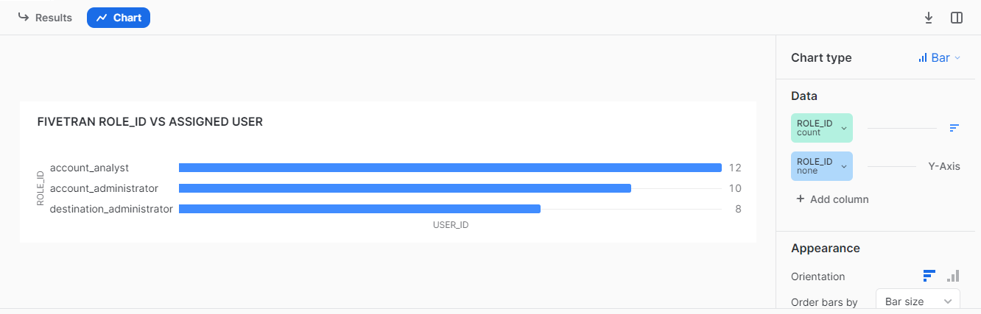

**4.4 FIVETRAN ROLE_ID VS ASSIGNED USER**

select user.given_name,rm.role_id

from FIVETRAN.FIVETRAN_LOG.USER

inner join

RESOURCE_MEMBERSHIP rm on user.id=rm.USER_ID;

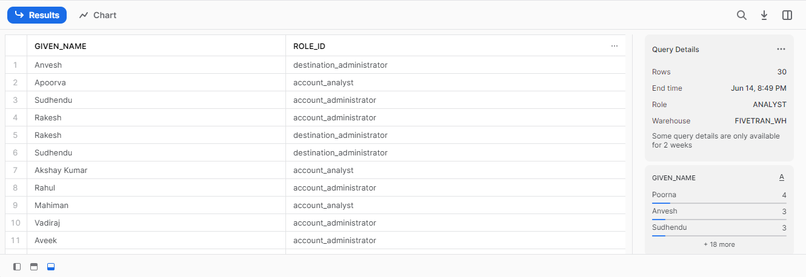

**4.5 Fivetran User Verification**

SELECT given_name,

CASE WHEN verified = 'TRUE' THEN 'VERIFIED'

WHEN VERIFIED = 'FALSE' THEN 'NOT VERIFIED'

END AS USER_INFO,

COUNT(*) AS USER_STATUS

FROM FIVETRAN.FIVETRAN_LOG.USER

GROUP BY GIVEN_NAME,VERIFIED ;

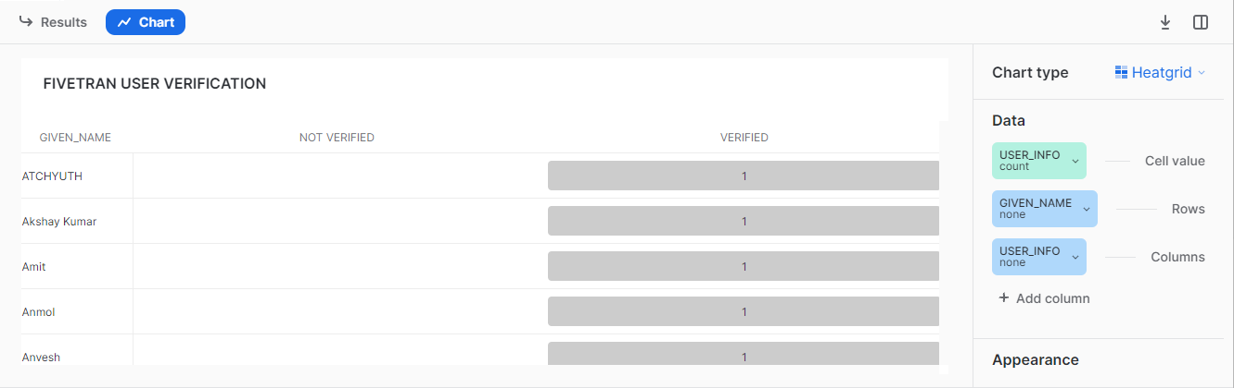

**4.6 WHO PAUSED THE CONNECTOR**

select message_event ,TRIM (parse_json(message_data):actor, '"') as user_mail_id ,time_stamp,connector_id

from "FIVETRAN"."FIVETRAN_LOG"."LOG"

where message_event='pause_connector' ;

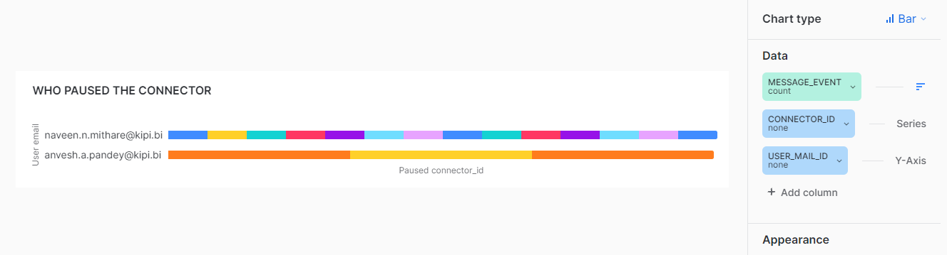

**4.7 NO OF SNOWFLAKE USERS**

SELECT GRANTEE_NAME AS USER,

IFNULL( GRANTED_BY , 'NONE' ) AS GRANTED_BY,

CREATED_ON FROM SNOWFLAKE.ACCOUNT_USAGE.GRANTS_TO_USERS WHERE GRANTED_TO='USER'

AND DELETED_ON IS NULL

AND ROLE= CURRENT_ROLE();

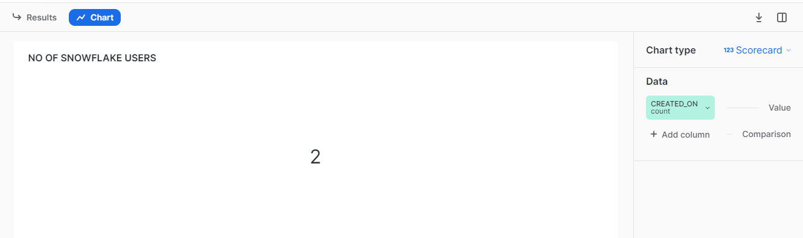

**4.8 WHO GRANTED CURRENT ROLE TO ROLES**

GRANTED_BY;

SHOW GRANTS OF ROLE CURRENT_ROLE();

SELECT GRANTEE_NAME AS ROLE,GRANTED_BY FROM SNOWFLAKE.ACCOUNT_USAGE.GRANTS_TO_ROLES WHERE NAME = CURRENT_ROLE() AND GRANTED_TO ='ROLE' AND DELETED_ON IS NULL; AND

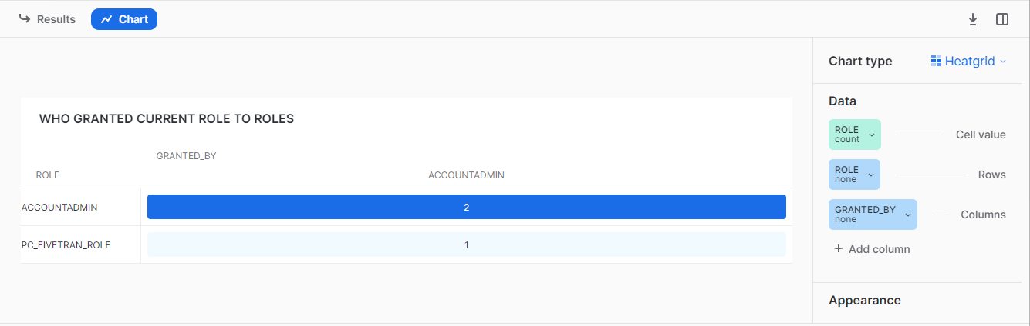

**4.9 WHO GRANTED CURRENT ROLE TO USERS**

SELECT GRANTEE_NAME AS USER,

IFNULL( GRANTED_BY , 'NONE' ) AS GRANTED_BY,

CREATED_ON FROM SNOWFLAKE.ACCOUNT_USAGE.GRANTS_TO_USERS WHERE GRANTED_TO='USER'

AND DELETED_ON IS NULL

AND ROLE= CURRENT_ROLE();

SELECT * FROM SNOWFLAKE.ACCOUNT_USAGE.GRANTS_TO_USERS;

